**Presque Isle County Road Commission**

**Minutes**

**November 1, 2023**

The regular meeting of the Board of Road Commissioners for Presque Isle County was held at the Road Commission office at 657 South Bradley, Rogers City, Michigan. Chairman Norman Quaine called the meeting to order at 8:30 a.m.

**Board Members Present:** Norman Quaine, Robert Macomber

**Excused:** Thomas Catalano

**Also Present**: Supt./Mgr David Kowalski, Clerk Anne Wirgau

**Visitors:** Clifford Tollini – Presque Isle County Commissioner, Steve Kroll – Manitou Shores Subdivision resident

***Minutes:***

A motion was made by Quaine (Macomber) to approve minutes from October 18, 2023 regular meeting as presented.

Ayes: All

***Accounts Payable:***

A motion was made by Quaine (Macomber) to approve the October 18, 2023 accounts payable in the amount of $298,163.62

Ayes: Quaine, Macomber

***Supt./Mgr Report:***

• The culvert order was placed with St. Regis on 10-18-23.

• McAllister Rentals has a man lift which meets our specifications and has relatively low hours at 2,150 hours. The price would be $45,900.00. Discussion was held, Supt./Mgr Kowalski stated he would ask them for a ninety-day warranty on major mechanical items such as drive train and engine. Item was moved to New Business for action

• Pine Lumber has provided a quote for materials for a Rogers City storage building in the amount of $10,545.25. Our crews can do the work and Supt./Mgr would obtain the building permit. The structure would be 28’ x 48’ with 10’ open walls. Discussion was held and item moved to New Business for action.

• Michigan CAT will appraise the Gradall machine for a possible trade on a mid-size (308 or 312) excavator. Additionally, they are a trailer dealer with two different brands and will quote a price for a 20-ton tag trailer.

• Winter sand mixing and hauling is complete for now. Sand is $8.05 per ton this year.

• The Road Commission has received a FOIA request for information on the possible Lost Lake relocation project.

• When Presque Isle Electric & Gas (PIE & G) subcontracts the fiber optic work we are not getting the proper permits and applications to work within the road right of way. Discussion was held and the Supt./Mgr was directed to contact PIE & G to find out which company is responsible for the permitting.

• Supt./Mgr attended the Rural Task Force (RTF) meeting last Friday. All changes were made to the 5 Year Plan and Illustrative List (see attached). The only task remaining for approval is to send NEMCOG Representative, Nico Tucker, a copy of the approved minutes.

• The external portion of the Rogers City truck garage floor drain is being replaced as it has collapsed and is no longer functional.

• Crews have been blading and preparing for winter maintenance. Some salting on the county and state trunkline has already occurred.

• Allan Berg has hired Wade Trim Engineering company for the possible Lost Lake Road relocation project. Wade Trim would like to do an online meeting with the Road Commission to discuss the scope of work and the process they need to do. Wade Trim has sent preliminary plans. Discussion was held. Commissioner Macomber suggested the letter previously sent to Mr. Berg be sent to Wade Trim prior to an online meeting as it outlines the Road Commission requirements for road construction.

• Aaron Hincka has requested an advance on the gravel crushing which will take place this fall or spring. We are tentatively scheduled to have 50,000 ton crushed. Supt./Mgr was directed to create necessary contract for the gravel purchase. Item moved to new business for action.

* A used one ton dually pickup with 100,000 miles has been located and may work for the Onaway garage plowing and cold patching. Discussion was held. Item moved to New Business for action.
* Supt./Mgr proved an estimate in the amount of $43,750.00 to Case Township Supervisor, Chris Bednark, for S. Ocqueoc Road seal coat & fog. This section of Ocqueoc Road is a local road south of Walker Highway in Section 16, T34N-R3E. The Case Township Board voted down the $28,437.50 Case Township cost share for the project. Discussion was held, Supt./Mgr may attend a township meeting to explain and educate the cost share requirements under Act 51 law for local roads. Our current cost share ratio is 65% township, 35% Road Commission.

***Visitors:***

Stephen Kroll, property owner with lots in Manitou Shores Subdivision, appeared before the Board to discuss a fence built in the right of way of Birch Street. Supt./Mgr met with Mr. Kroll yesterday and measured the right of way and placement of fence. The 66’ foot right of way has a fence constructed at 56’ feet into the road by Clarence Zwolinski. Supt./Mgr Kowalski showed photos of the area. Discussion was held regarding the history of the undeveloped road and a previous request to Zwolinski to remove the fence. Commissioner Macomber noted the fence was a clear encroachment and its placement would prevent any ditching if needed in the future.

Supt./Mgr was directed by the Board to send Mr. Zwolinski a letter instructing him to remove the fence from the right of way by spring of 2024.

Mr. Kroll thanked the Board and left the meeting at 9:36 a.m.

***Unfinished Business:***

None

***New Business:***

A motion was made by Macomber (Quaine) to authorize the purchase of materials from Pine Lumber for a storage building at the Rogers City location in the amount of $10,545.25.

Ayes: Macomber, Quaine

A motion was made by Quaine (Macomber) to authorize the purchase of a used Genie manlift from McAllister Rentals in the amount of $45,900.00.

Ayes: Quaine, Macomber

Commissioner Macomber offered the following resolution and moved for its adoption:

**RESOLUTION**

**Presque Isle County Road Commission**

Be it resolved that

CONTRACT No. 23-5422, Control Section 71000, Job Number 218938CON

by and between the

MICHIGAN DEPARTMENT OF TRANSPORTATION

and the

Presque Isle County Road Commission

is hereby accepted.

The following Official(s) is/are authorized to sign the said contract:

David A. Kowalski, Supt./Mgr

Supported by Commissioner Quaine

ADOPTED: AYES: Quaine, Macomber

NAYES: None

ABSENT: Catalano

A motion was made by Macomber (Quaine) to authorize an advance payment of $20,000.00 to be paid to Aaron Hincka for gravel crushing royalties at the Schaudt Hill gravel pit.

Ayes: Macomber, Quaine

A motion was made by Quaine (Macomber) to authorize purchase of a used dually pickup up to $14,500.00 subject to the mechanic’s inspection and approval.

Ayes: Quaine, Macomber

Supt./Mgr discussed the possibility of laddering the purchase of Foremen pickups. Posen Foreman truck has the highest mileage currently. Additionally, he is recommending the purchase of another used Fastenal pickup (2 x 4, standard cab, 8’ box) for use in the fleet. Supt./Mgr will bring information to the Board at a future meeting.

The next regular meetings of the Presque Isle County Road Commission will be, Wednesday, November 22, 2023 at 8:30 a.m. and Wednesday, December 6, 2023 at 8:30 a.m.

With no further business to come before the Board, Chairman Quaine adjourned the meeting at 10:12 a.m.

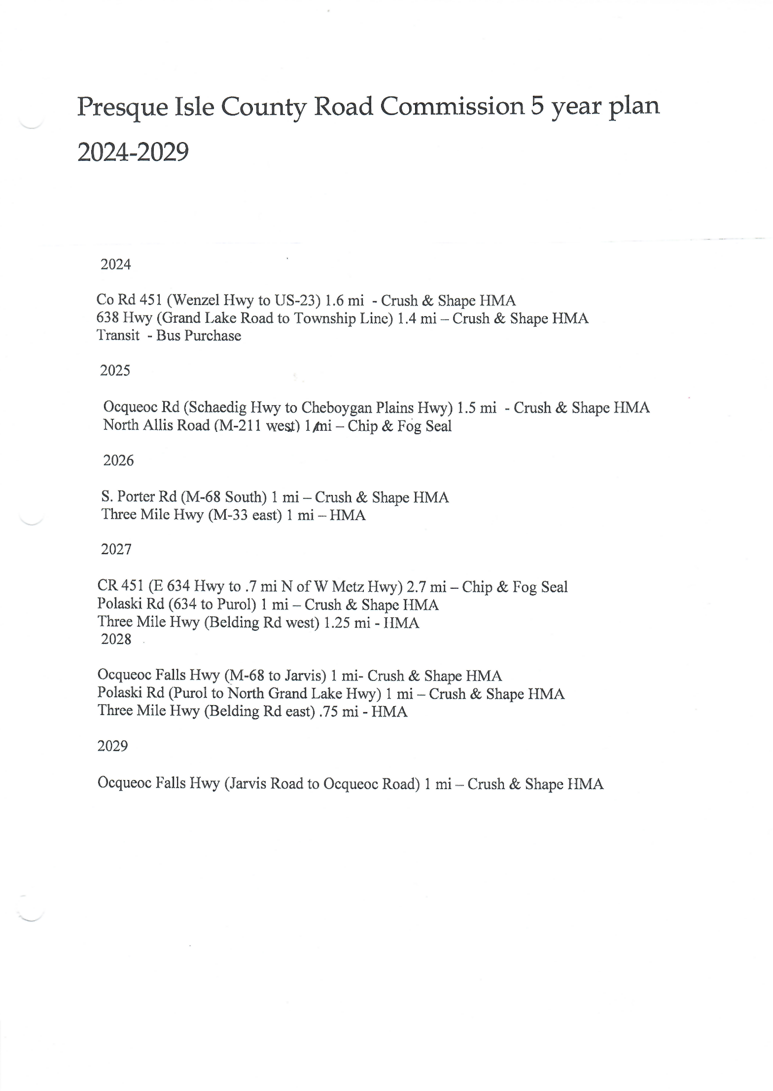

10-2023 Illustrative List as suggested by Mark

County-wide Pavement Marking No Change

N. Allis Hwy Cheb CL to M211 1.0 Miles Chip/Seal

N. Allis Hwy M-211 to Roost Road 2.7 Miles Chip/seal

N. Allis Hwy Roost Road to N. Cold Creek 2.3 Miles Chip/Seal

N. Allis Hwy N. Cold Creek to N. Ocqueoc 2.2 Miles Chip/seal

N Ocqueoc Rd Cheb Plains to US- 23 1.7 Miles HMA Overlay

N Ocqueoc Rd N Allis Hwy to Schaedig 2.5 Miles HMA Overlay

N. Ocqueoc Rd Twin Sch to N Allis 2.0 Miles HMA Overlay

N. Ocqueoc Rd M-68 to Twin Sch 1.9 Miles HMA Overlay

S Ocqueoc Rd Walker to M-68 2.2 Miles HMA Overlay

CR 451 E 638 to .7 mi N of W Metz (JN 123267) 1.5 Miles Resurface

Heythaler S Karsten to US23 4.0 Miles Chip/Seal

Heythaler/S Ward Br Karsten to M68 3.0 Miles Chip/Seal

CR634 Hwy Leer Rd west 4.0 Miles Chip/Seal

CR 638 Lost Lake to Kelly Drive 2.0 Miles Crush & Shape

E 638 Hincka to M65 1.0 Mile Crush & Shape

N Ward Branch/Church M-68 to Angle 2.0 Miles HMA Overlay

Leer Rd Thunder Bay Hwy to CL 2.1 Miles Chip/Seal

Three Mile Hwy South Porter West 1.0 Miles HMA